KILSYTH MEDICAL PARTNERSHIP ONLINE SERVICES

Patients have the ability to book GP appointments and re-order their repeat medications online.

You must register first to be able to use Online Services. A registration form (attached) needs to be completed for each family member that wants to be able to book appointments or re-order scripts online. Parents will need to complete a form for each child under 16. You can use your own email address for your child(ren) but they must have their own username and password. For confidentiality reasons Online Services is set to recognise a patient as being an adult once they reach the age of 16 years. Therefore once a child reaches the age of 16 they will need to re-register giving their own individual email address.

Once a registration form has been completed it should be handed in to the health centre in person and with proof of identification. A member of staff will enter the details onto the patients’ electronic file and a letter showing the relevant registration details will be generated – see the attached example. Please note that there will be an expiry date on the letter for the registration token. You must activate your account before the expiry date otherwise you will have to start the process again with another registration form.

N.B. If you do not have a valid email address then you cannot register for Online Services.

KILSYTH MEDICAL PARTNERSHIP ONLINE SERVICES

The letter generated by the receptionist will look similar to this:

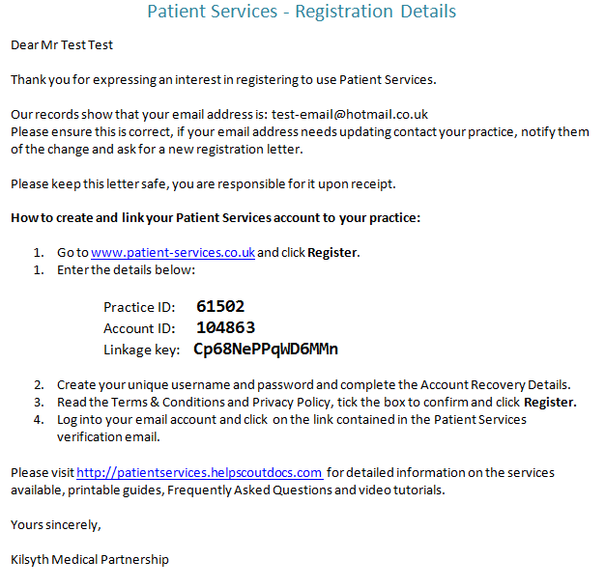

Once you receive this letter, you go to the website as shown above where you can register your account with the above details. You will need to create a username and password, and then activate your account. Following this process, you will be able to login and use the online services.

KILSYTH MEDICAL PARTNERSHIP ONLINE SERVICES

There are four online account statuses:

- Created
- Registered
- Active
- Locked

When a patient has supplied their email address, the online account is then created by the practice and a Registration Confirmation Letter is generated and given to the patient – the account is now created.

When the patient has completed the online registration process, creating a username and password, but not activating the account by acknowledging the confirmation email – the status will be registered.

When the patient has activated the online account by following the link in the confirmation email – the account will be active.

After 5 unsuccessful log-in attempts the patient’s online account will be locked temporarily for 4 hours – account will be locked.

After the 4 hours lock period, the patient’s online account will unlock automatically and the account will once again be active.

A patient can choose to opt out of online services at any time by putting their request in writing to the practice.

The practice also reserves the right to disable any account if a patient is seen to be abusing the service.

Online Patient Services - Patient registration form
To register for this online service, please complete the form below and return it to the practice in person, along with a valid form of identification, for example your passport or driving license. Once you are registered the practice will give you the information that will enable you to create a username and password.

Patient details | Please complete in BLOCK CAPITALS
Patient forename(s):
Patient surname:
Date of birth:
(DD/MM/YYYY)
A valid email address is required to set up your online account.  Email address: | Please write clearly - differentiate between upper and lowercase letters and clearly indicate any numbers included in your address. For confidentiality reasons, please do not use the same email for different users.
Mobile number:
Signature:

Date:
Completing the form on behalf of the patient?
Print forename(s):
Print surname:
Relationship:
Signature:

Date:

Staff use only
Patient ID seen | Yes No If no, why:
Type of ID
Staff name
Date

